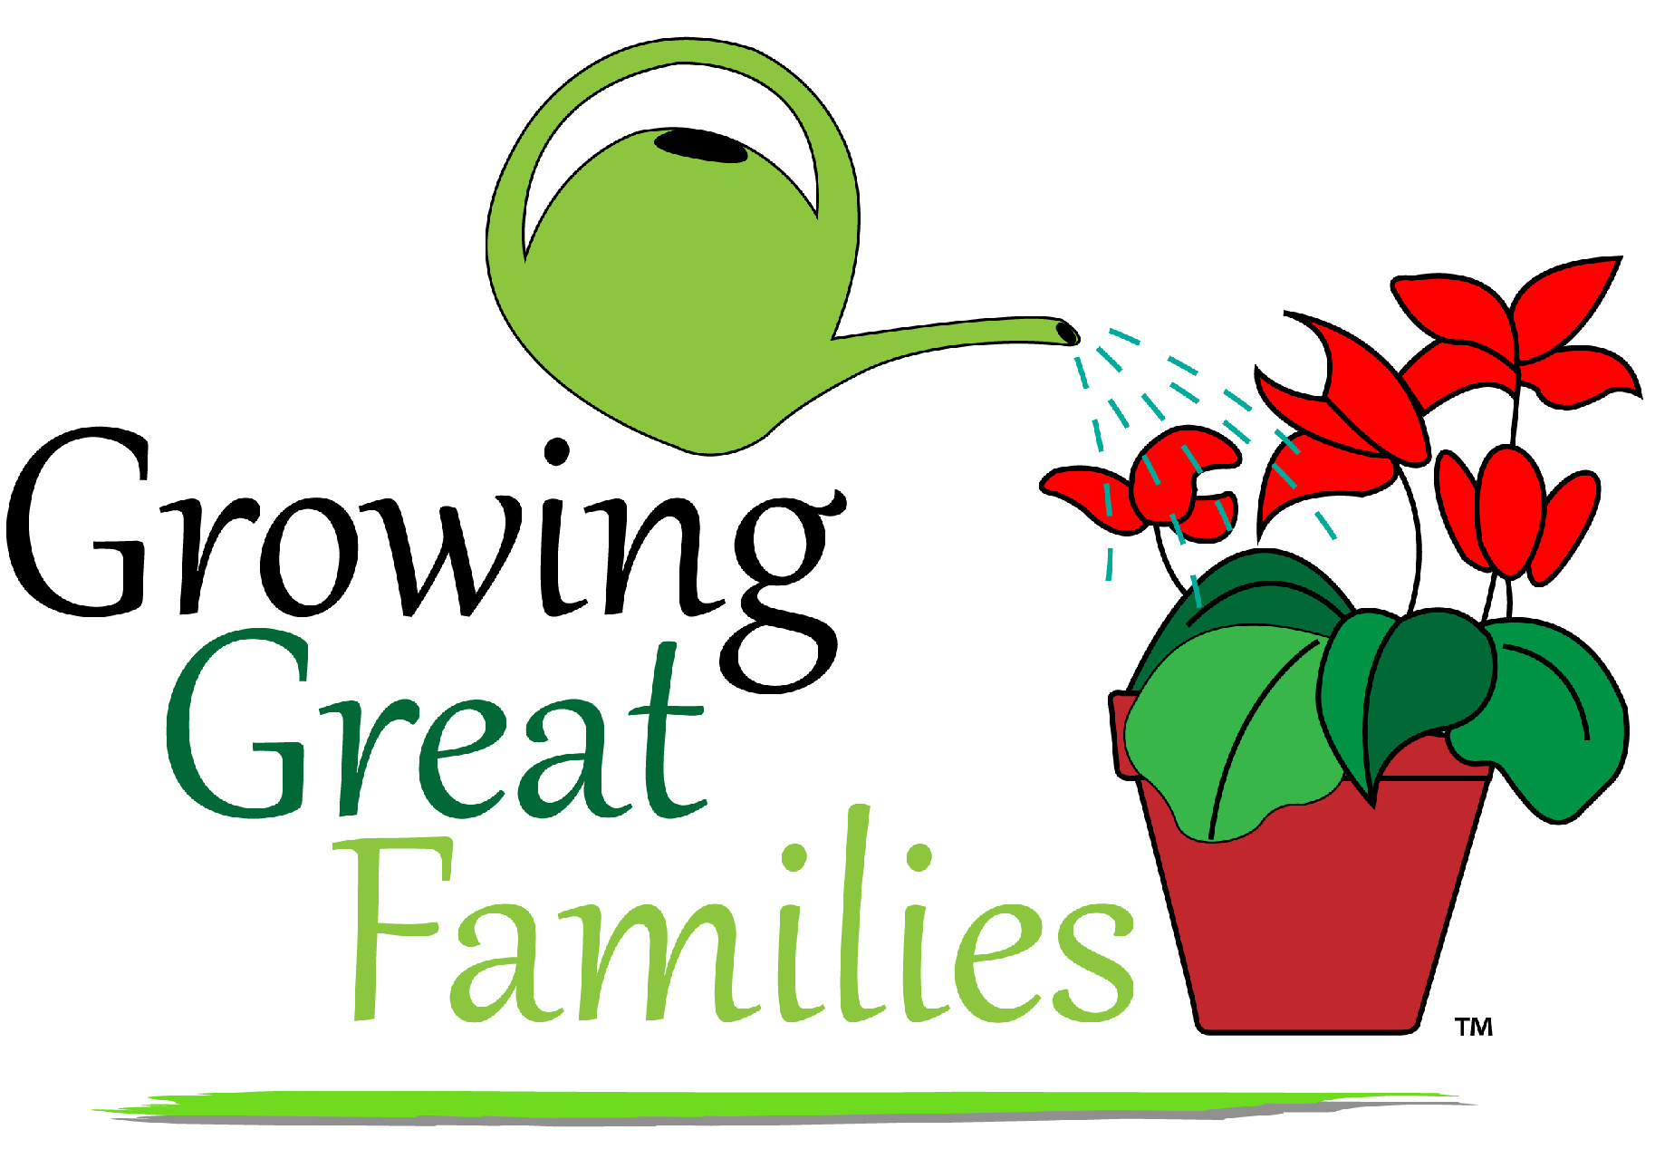November 4, 2014

Dear

Sarah Jecks and I, co-chairpersons of the 2nd annual Growing Great Families Conference, are hoping that we can talk with you and your staff about this great event. Last February the Silvis School District introduced the concept of a creating a conference for parents and guardians. We all know how revitalized we as educators are when we return from a conference and the purpose of this event was to provide families with the same opportunity. The conference was well-received, and the need was identified.

In planning this year’s conference the committee decided to open it up to all families in the United Township High School feeder districts. We have had our first meeting and plans have started to be formed. Before we progress too far, we want to get input from teachers in the other feeder districts about topics and presenters that might be of interest to the parents in those districts.

To that end we are asking if Sarah and/or I can come to your next faculty meeting. We would like to take 5 minutes to share information about the conference and solicit ideas for presentations. We will even bring refreshments to share!

If you would be willing to let us do this, please contact us with the date and time. We will let you know which of us will be able to attend.

Thank you for any consideration you can give our request.

Sincerely,
Dr. Debbie Lee, Ed.D.
DM-Lee3@wiu.edu

Sarah Jecks, M.S.Ed.
sarah.jecks@silvis34.com

