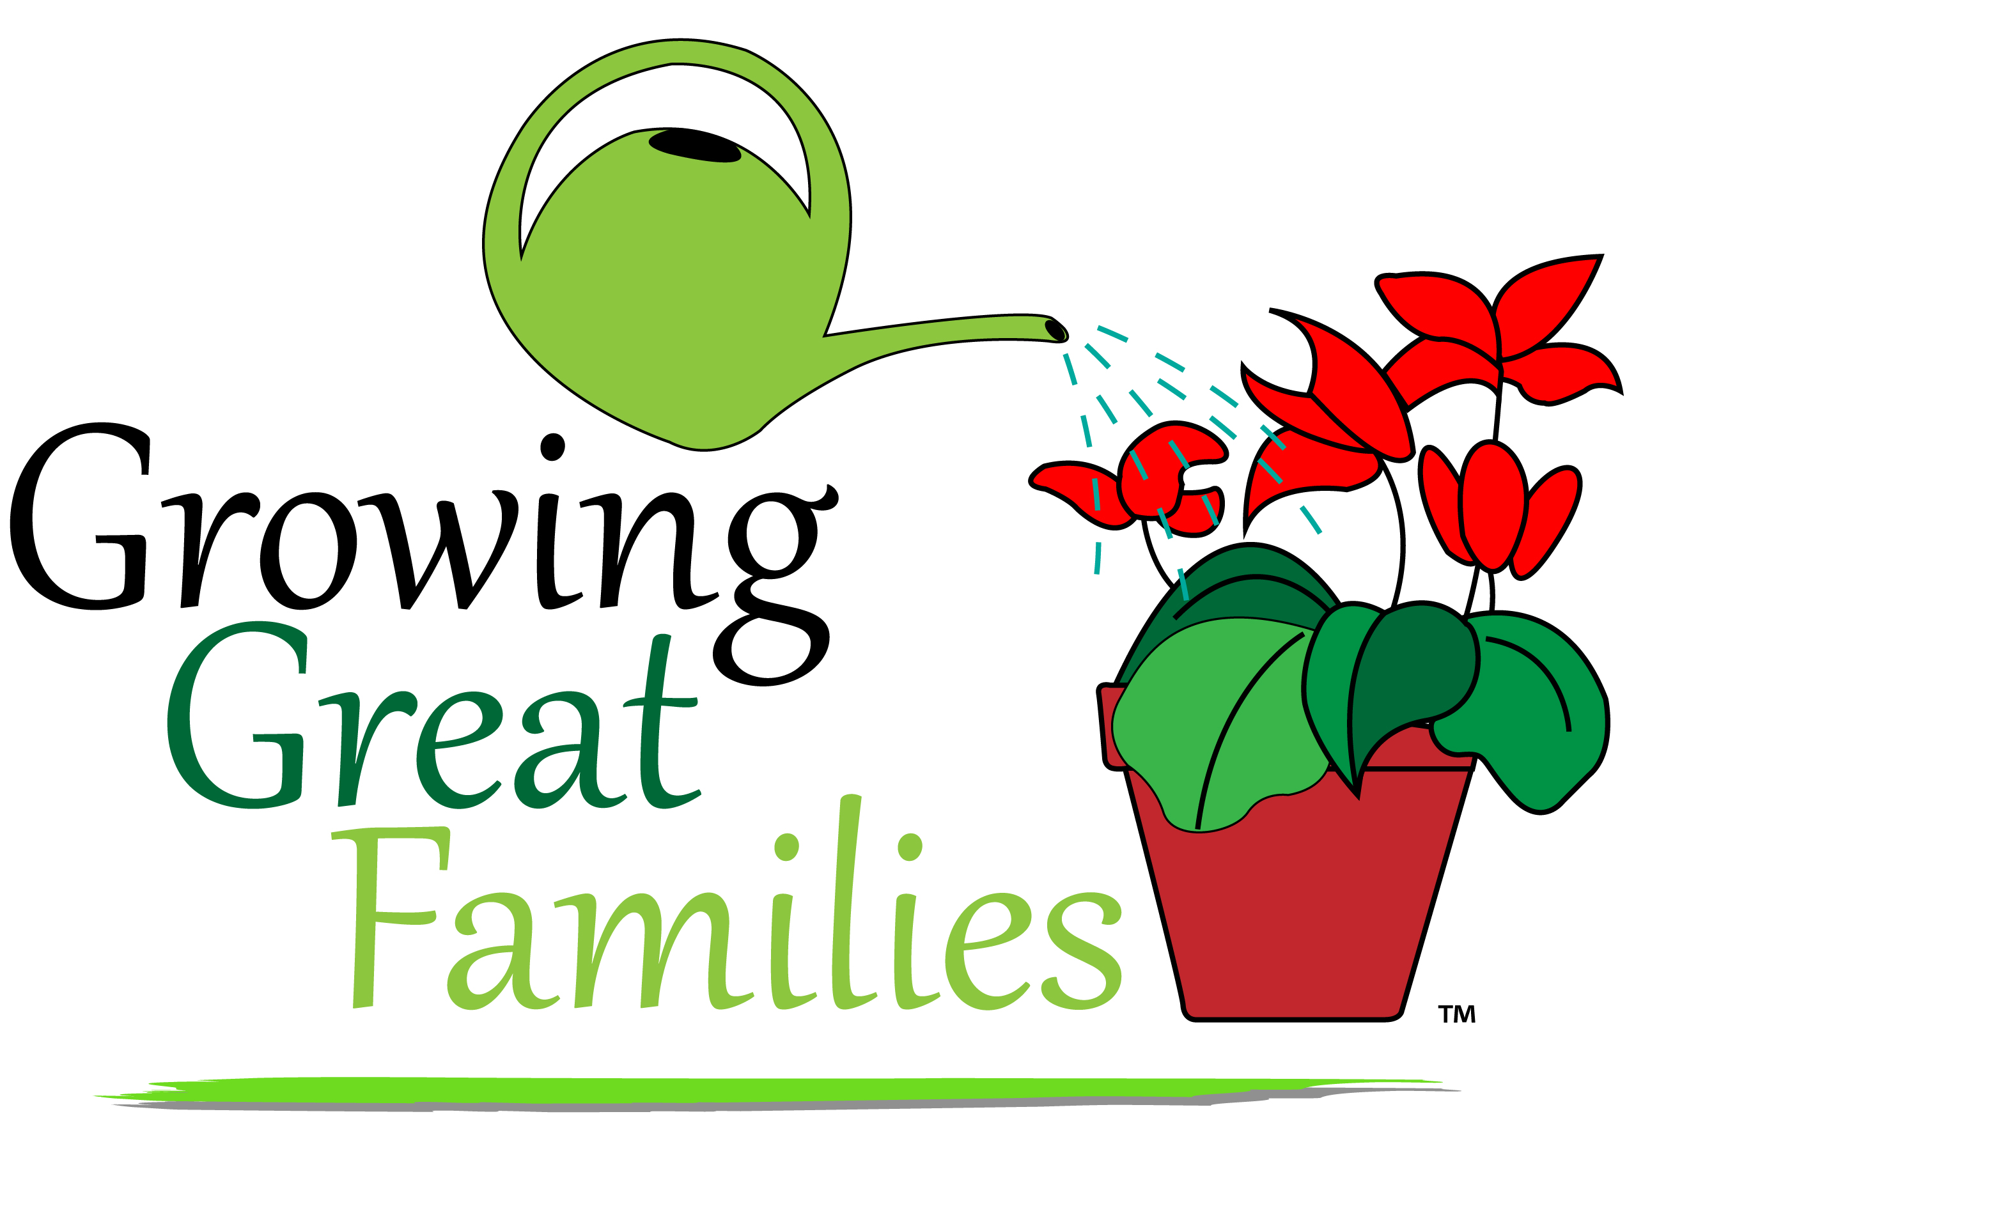

**CONFERENCE REGISTRATION**

Parent/Guardian Name(s): _______________________________________

School: ______________________________________

School District: _____________________________

Number of adults attending: _______________

Number of children needing childcare: ______

Ages of children needing childcare:______________

**TEAR OFF AND RETURN THIS COMPLETED**

**REGISTRATION FORM TO YOUR CHILD’S SCHOOL**

**OFFICE BY FRIDAY, JANUARY 30.**

|  |  |  |  |
| --- | --- | --- | --- |
| **8:00** | **Registration/Breakfast** | | |
| **8:30** | **Keynote: Dr. Donna McCaw** | | |
| **9:00** | **Person to Person: Making Positive Relationships Happen**  Dr. Leslie O’Ryan | **Facebook Frenzy! Understanding Social** **Media** Amanda Stablein | **Incredible Years Parent Education**  Brittany Coopman & Amanda Dybek |
| **Family Budgeting**  Scott Beeler | **Crafts on the Cheap**  Angie Banks | **What’s It Like Being a Teenager?**  Junior High Student Panel |
| **9:45** | **Preparing Your Student to Take the PARCC Test**  Mary Rossmiller,  Kirsten Kearns, &  Molly Hayes | **Expanding Learning Through Nursery Rhymes with Young Children**  Angie Banks | **Simply Crocked: Crockpot Cooking**  Tammy Valdes |
| **Incredible Years Parent Education**  Brittany Coopman & Amanda Dybek | **Handling Parental Guilt**  Angie Kendall | **Tips to Capture the Best Photos of Your Children**  Brianna Casarotto |
| **10:30** | **Kids Build and Learn: Fun Science at Home: Ages 4-8**  R. J. Windt | **Understanding the Common Core Standards**  Paula Spencer &  Kim Bultynck | **Raising a Relative’s Child(ren) – Help is Out There**  Kim Corts |
| **Couponing 101: Modern Day Penny Pinching**  Heather Pizano | **Stress: What It Is and How to Deal With It**  Becky Kurt | **Paying for Childcare**  Amy Shelton |
| **11:15** | **Kids Build and Learn: Fun Science at Home: Ages 9-13**  R. J. Windt | **Raising a Bilingual Child**  Rose Hernandez | **Mind-Body Tools for Health, Emotions, and Learning**  Dr. Andrea Hyde & Diane Hudson |
| **Children’s Health**  America Bunker | **What is Quality Childcare?**  Brianna Skovronski | **Special Education Rights and Responsibilities**  Ginny Manske |