8:00 | Registration and Breakfast
8:30 | Keynote: Dr. Donna McCaw “Full Service”
9:00 | Library | Room 164 | Room 165 | Room 170 | Room 172 | Art
 | Person to Person: Making Positive Relationships Happen  Leslie O’Ryan | Facebook Frenzy! Understanding Social Media  Amanda Stablein | Incredible Years Parent Education  Brittany Coopman &  Amanda Dybek | What’s It Like Being a Teenager?  Junior High Student Panel | Family Budgeting  Scott Beeler | Crafts on the Cheap  Angie Banks
 | Learn about skills to use in developing and maintaining meaningful, supportive relationships, and teaching your children about such relationships. | Everyone is using Facebook, including kids! Learn how to best take advantage of this and other social media and what you need to keep in mind when your children use it. | “How do I raise these kids?!”  Come learn the key points of the Incredible Years Parent Education program, including an activity. | Sit and talk with a panel of junior high experts.....junior high students themselves! Ask questions, and come away with a hopefully honest feel for what junior high is really like. | Learn how to balance your household expenses with your income. | Come gets some ideas and samples of inexpensive crafts to do with children.
9:45 | Teachers’ Lounge | Room 164 | Room 165 | Room 170 | Room 172 | Art
 | Simply Crocked: Crockpot Cooking  Tammy Valdes | Handling Parental Guilt  Angie Kendall | Incredible Years Parent Education  Brittany Coopman &  Amanda Dybek | Tips to Capture the Best Photos of Your Children  Brianna Casarotto | Preparing Your Student to Take the PARCC Test  Mary Rossmiller, Kirsten Kearns, & Molly Hayes | Expanding Learning Through Nursery Rhymes  Angie Banks
 | Come find out how to prepare healthy family dinners that are both quick and easy! | All of us make mistakes as parents. Learn how to handle guilt when we are less than perfect, learn from the experience, and move on. | Come learn the key points of the Incredible Years Parent Education program, including an activity.  (REPEATED SESSION) | Learn ways to get great photos without spending a fortune. Come away with ideas on taking, developing and printing pictures and making albums. | We will share what we have learned about the PARCC test, how we are preparing our students for the test, and how parents can help at home. | Learn how to incorporate math, reading, problem solving skills, and more with your favorite nursery rhymes!
10:30 | Library | Room 164 | Room 165 | Room 169 | Room 172 | Art
 | Couponing 101: Modern Day Penny Pinching  Heather Pizano | Raising a Relative’s Child(ren) – Help is Out There  Kim Corts | Paying for Childcare  Amy Shelton | Stress: What It Is and How to Deal With It  Becky Kurt | Understanding the Common Core Standards  Paula Spencer &  Kim Bultynck | Kids Build and Learn: Fun Science at Home: Ages 4-8  R. J. Windt
 | Learn about couponing and saving money on everyday items such as gasoline, prescriptions, restaurant deals, etc. | Learn about the various programs and services that can help individuals/ families who are raising a young relative. | This presentation will provide an overview of how the Child Care Assistance Program assists families in Illinois pay for child care. | After examining the effects of stress, we’ll look at strategies to deal with it. | Come find out what the Common Core is, how it has changed education, and what you can do at home to help your child. | Come get ideas for many projects that can be done with common household items and can provide hours of fun learning.
11:15 | Music | Room 164 | Room 169 | Room 170 | Room 171 | Art
 | Mind-Body Tools for Health, Emotions, and Learning  Andrea Hyde &  Diane Hudson | Raising a Bilingual Child  Rose Hernandez | Children’s Health  America Bunker | What is Quality Childcare?  Brianna Skovronski | Special Education Rights and Responsibilities  Ginny Manske | Kids Build and Learn: Fun Science at Home: Ages 9-13  R. J. Windt
 | Come find out the benefits of yoga for children, learn a few poses, and receive information about free or low costs local resources for adults and kids. | Raising a bilingual child can be both challenging and rewarding. Come get tips to make is easier. | This presentation will cover the basics of lice, hygiene and what to do if your child is sick. | Learn about the different child care options available, how to recognize a quality child care program and how to find these programs. | Get a brief overview of parental rights and responsibilities, talk about the differences, and learn how to best serve your child’s needs. | Come get ideas for many projects that can be done with common household items and that can provide hours of fun learning.

SPONSORED BY
Horace Mann Investors, Inc.
Silvis Optimist Club
Silvis Rocket Boosters
Silvis School District
United Education Foundation
Western Illinois University, QC

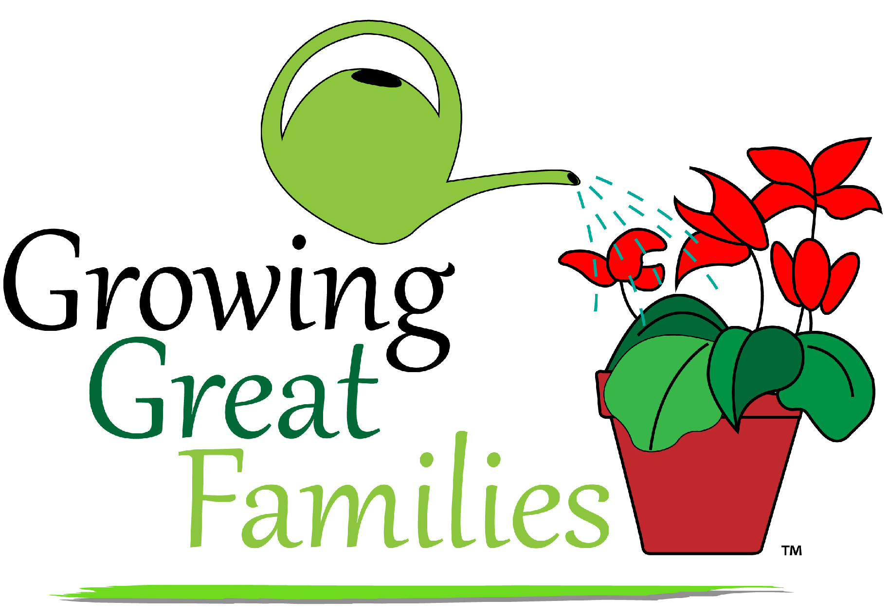
CONFERENCE

February 7, 2015
Silvis, IL

