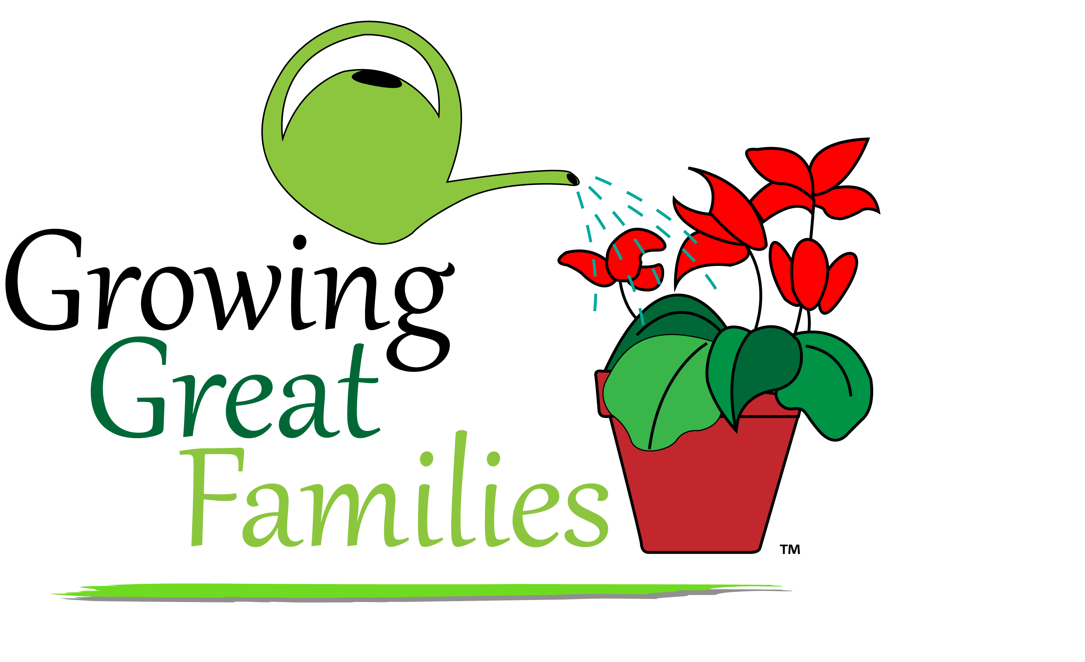
CONFERENCE

When: Saturday, February 7, 2015
8:00am- Noon
Weather date: February 28

Where: George O. Barr School
1305 5th Ave., Silvis, IL
309-792-0639
Cost: Free!
Breakfast and childcare included
Who should attend: All parents and guardians raising children Pre-K through 8th grade
Pre-registration is required so we
can have adequate food and
childcare.

SEND IN YOUR REGISTRATION FORM TODAY! IF YOU DON’T HAVE ONE, YOU CAN GET ONE FROM YOUR
CHILD’S TEACHER OR THE SCHOOL OFFICE!
COME WITH A FRIEND!!

CONFERENCE

When: Saturday, February 7, 2015
8:00am- Noon
Weather date: February 28

Where: George O. Barr School
1305 5th Ave., Silvis, IL
309-792-0639
Cost: Free!
Breakfast and childcare included
Who should attend: All parents and guardians raising children Pre-K through 8th grade
Pre-registration is required so we
can have adequate food and
childcare.

SEND IN YOUR REGISTRATION FORM TODAY! IF YOU DON’T HAVE ONE, YOU CAN GET ONE FROM YOUR
CHILD’S TEACHER OR THE SCHOOL OFFICE!
COME WITH A FRIEND!!

